XGBoost (eXtreme Gradient Boosting) is a popular and powerful machine learning algorithm known for its speed and performance in structured/tabular data problems. It's an implementation of gradient boosted decision trees designed for efficiency, flexibility, and scalability. Here's a breakdown of its key features and how it works:
1. **Gradient Boosting**: XGBoost belongs to the family of ensemble learning methods, specifically gradient boosting. Gradient boosting is a technique where models are built sequentially, with each new model attempting to correct the errors made by the previous ones.
2. **Decision Trees**: XGBoost builds a series of decision trees during training. Each tree attempts to predict the target variable, and the predictions from all trees are combined to make the final prediction.
3. **Regularization**: XGBoost provides several regularization parameters to prevent overfitting, such as max_depth (maximum depth of a tree), min_child_weight (minimum sum of instance weight needed in a child), and gamma (minimum loss reduction required to make a further partition on a leaf node).
4. **Gradient Optimization**: XGBoost optimizes the gradient descent algorithm for boosting through advanced techniques, such as parallelization, approximate tree learning, and hardware optimization.
5. **Support for Custom Objectives and Evaluation Metrics**: XGBoost allows users to define custom objective functions and evaluation metrics, enabling the model to be customized for various types of tasks and datasets.

6. **Feature Importance**: XGBoost provides a built-in method to assess the importance of each feature in the prediction, which can be helpful for feature selection and understanding the model.
7. **Scalability**: XGBoost is designed for scalability and can handle large datasets efficiently. It supports parallel and distributed computing, making it suitable for both single machines and distributed environments.
Overall, XGBoost is widely used in competitions on platforms like Kaggle and is often the algorithm of choice for structured/tabular data problems due to its excellent performance and versatility.
A simplified explanation of the mathematics behind XGBoost:
1. **Loss Function**: XGBoost minimizes a loss function that measures the difference between the actual and predicted values. Common loss functions include squared error for regression problems and logistic loss for classification problems.
2. **Gradient Boosting**: XGBoost builds a series of decision trees sequentially. At each step, it fits a new tree to the residuals (the differences between actual and predicted values) of the previous predictions.
3. **Tree Construction**: To construct each tree, XGBoost uses a technique called gradient boosting. It starts with a simple tree and iteratively adds more trees to improve the model's performance. Each new tree is built to correct the errors made by the ensemble of previous trees.
4. **Regularization**: XGBoost incorporates regularization techniques to prevent overfitting. It adds penalties to the loss function based on the complexity of the trees, encouraging simpler models.
5. **Optimization**: XGBoost optimizes the tree construction process by using gradient descent. It calculates the gradients of the loss function with respect to the model's predictions and updates the model parameters (tree structure and leaf values) in the direction that minimizes the loss.
6. **Feature Importance**: XGBoost calculates feature importance by examining how much each feature contributes to reducing the loss function across all the trees in the ensemble. Features that are frequently used in splitting nodes or lead to larger reductions in the loss are considered more important.
XGBoost combines gradient boosting with decision trees and regularization techniques to build a powerful ensemble model that minimizes a specified loss function. The algorithm iteratively improves its predictions by adding new trees and optimizing their structure and parameters.
Let’s start with our training dataset which consists of five people. We recorded their ages, whether or not they have a master’s degree, and their salary (in thousands). Our goal is to predict Salary using the XGBoost algorithm.


Step 1: Make an Initial Prediction and Calculate Residuals
This prediction can be anything. But let’s assume our initial prediction is the average value of the variables we want to predict.
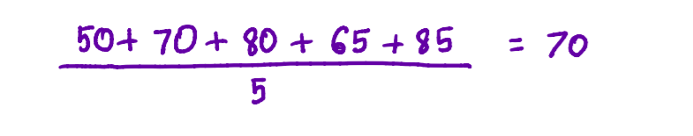
We can calculate residuals using the following formula:
Here, our Observed Values are the values in the Salary column and all Predicted Values are equal to 70 because that is what we chose our initial prediction to be.


Step 2: Build an XGBoost Tree
Each tree starts with a single leaf and all the residuals go into that leaf.

Now we need to calculate something called a Similarity Score of this leaf.
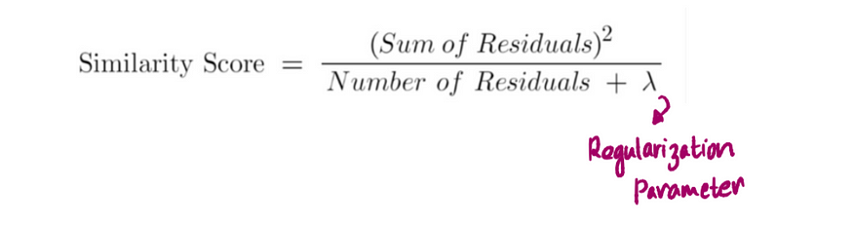
λ (lambda) is a regularization parameter that reduces the prediction’s sensitivity to individual observations and prevents the overfitting of data (this is when a model fits exactly against the training dataset). The default value of λ is 1 so we will let λ = 1 in this example.

Now we should see if we can do a better job clustering the residuals if we split them into two groups using thresholds based on our predictors — Age and Master’s Degree?. Splitting the Residuals basically means that we are adding branches to our tree.
First, let’s try splitting the leaf using Master’s Degree?

And then calculate the Similarity Scores for the left and right leaves of the above split:
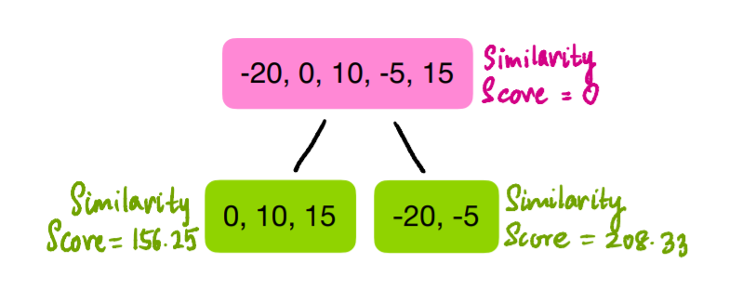
Now we need to quantify how much better the leaves cluster similar Residuals than the root does. We can do this by calculating the Gain of splitting the Residuals into two groups. If the Gain is positive, then it’s a good idea to split, otherwise, it is not.
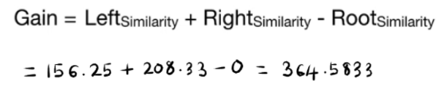
Then we compare this Gain to those of the splits in Age. Since Age is a continuous variable, the process to find the different splits is a little more involved. First, we arrange the rows of our dataset according to the ascending order of Age. Then we calculate the average values of the adjacent values in Age.
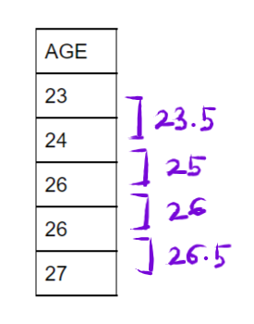
Now we split the Residuals using the four averages as thresholds and calculate Gain for each of the splits. The first split uses Age < 23.5:

For this split, we find the Similarity Score and Gain the same way we did for Master’s Degree?
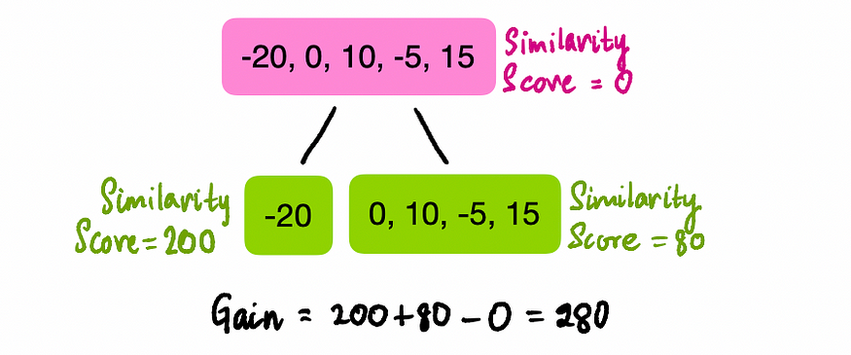
Do the same thing for the rest of the Age splits:
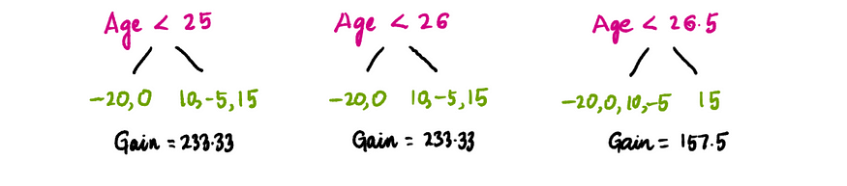
Out of the one Mater’s Degree? split and four Age splits, the Master’s Degree split has the greatest Gain value, so we’ll use that as our initial split. Now we can add more branches to the tree by splitting our Master’s Degree? leaves again using the same process described above. But, only this time, we use the initial Master’s Degree? leaves as our root nodes and try splitting them by getting the greatest Gain value that is greater than 0.
Let’s start with the left node. For this node, we only consider the observations that have the value ‘Yes’ in Master’s Degree? because only those observations land in the left node.

So we calculate the Gain of the Age splits using the same process as before, but this time using the Residuals in the highlighted rows only.
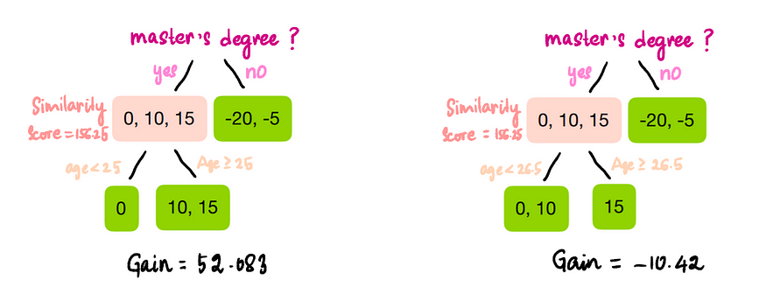
Since only Age < 25 gives us a positive Gain, we split the left node using this threshold. Moving onto our right node, we only look at values with ‘No’ values in Master’s Degree?

We only have two observations in our right node, so the only split possible is Age < 24.5 because that is the average of the two Age values in the highlighted rows.
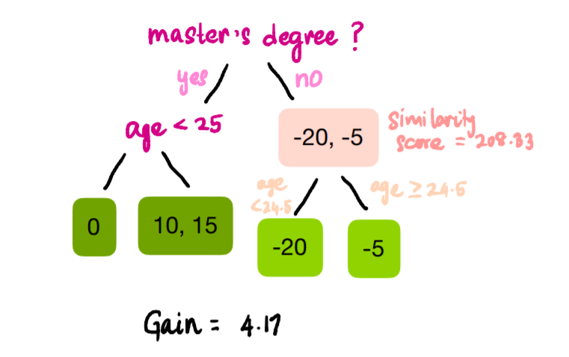
The Gain of this split is positive, so our final tree is:
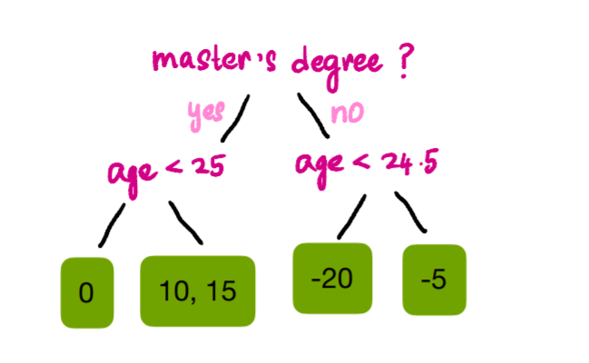

Step 3: Prune the Tree
Pruning is another way we can avoid overfitting the data. To do this we start from the bottom of our tree and work our way up to see if a split is valid or not. To establish validity, we use γ (gamma). If Gain — γ is positive then we keep the split, otherwise, we remove it. The default value of γ is 0, but for illustrative purposes, let’s set our γ to 50. From previous calculations we know the Gain values:
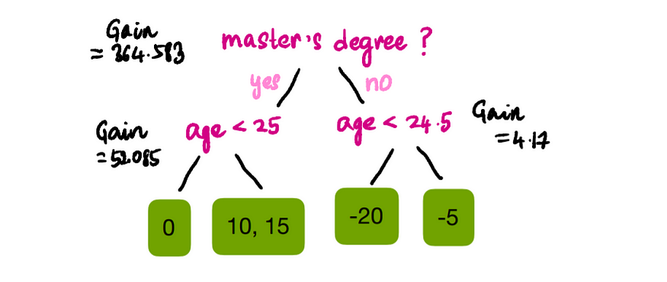
Since Gain — γ is positive for all splits except that of Age < 24.5, we can remove that branch. So the resulting tree is:
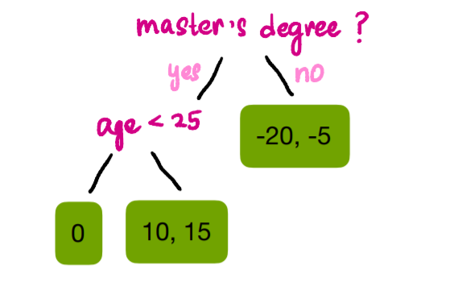

Step 4: Calculate the Output Values of Leaves
We are almost there! All we have to do now is calculate a single value in our leaf nodes because we can not have a leaf node giving us multiple outputs.
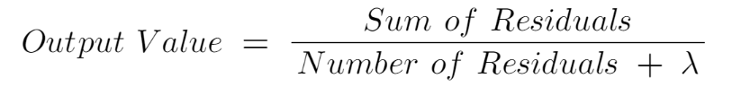
This is similar to the formula to calculate Similarity Score except we are not squaring the Residuals. Using the formula and λ = 1, *drum roll* our final tree is:
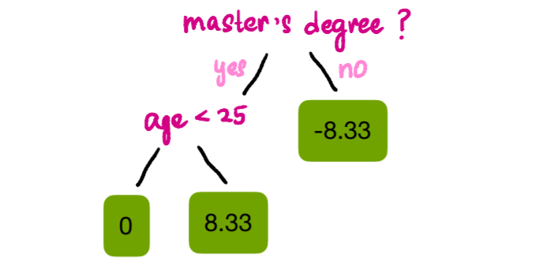

Step 5: Make New Predictions
Now that all that hard model building is behind us, we come to the exciting part and see how much our predictions improve using our new model. We can make predictions using this formula:
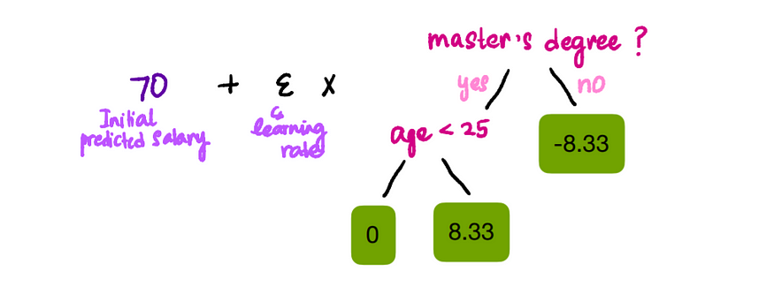
The XGBoost Learning Rate is ɛ (eta) and the default value is 0.3. So the predicted value of our first observation will be:

Similarly, we can calculate the rest of the predicted values:
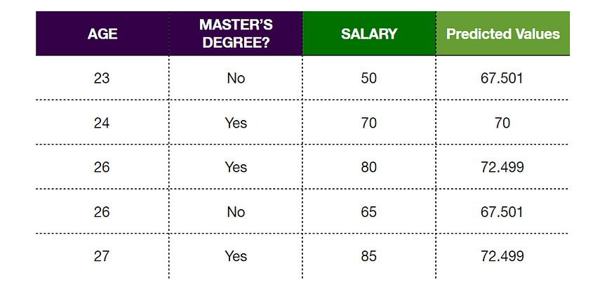

Step 6: Calculate Residuals Using the New Predictions
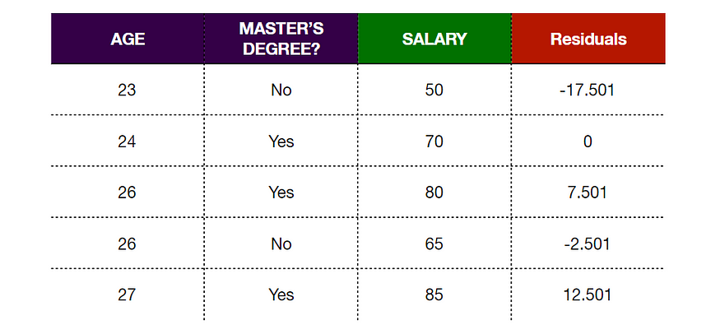
We see that the new Residuals are smaller than the ones before, this indicates that we’ve taken a small step in the right direction. As we repeat this process, our Residuals will get smaller and smaller indicating that our predicted values are getting closer to the observed values.

Step 7: Repeat Steps 2–6
Now we just repeat the same process over and over again, building a new tree, making predictions, and calculating Residuals at each iteration. We do this until the Residuals are super small or we reached the maximum number of iterations we set for our algorithm. If the tree we built at each iteration is indicated by Tᵢ, where i is the current iteration, then the formula to calculate predictions is:

